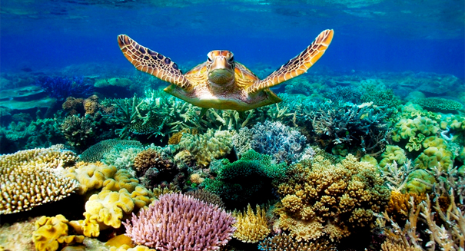**CODING CORALS**

**Nai Ze Ming**

**U1640413L**

An individual report on the analytical process to study the resilience of corals in the North Pacific Ocean to climate change. The computational programme, MATLAB, was used to assist in the research of this project

**1. Introduction**

Background

Cyclic El Nino patterns[1] are known to warm the Pacific Ocean and cause coral bleaching (NOAA, 2017). During bleaching, corals expel their symbiotic algae and turn white (NOAA, 2017). In recent years, rising temperatures and changing climate have extended El Nino years, causing prolonged and more frequent bleaching events (NOAA, 2016). Extended bleaching events reduce coral recovery period[2] and may compromise their resilience towards stressful conditions (NOAA, 2016). Reduction in corals are detrimental to the ecosystem since coral reefs are not only vital for supporting the marine environment, they provide numerous ecosystem services to both humans and animals (NOAA, 2017).

Therefore, our group decided to investigate the correlation between climate change and coral population in the North Pacific Ocean to analyse the resilience of corals. 7 parameters related to climate change were analysed. They are Sea Surface Temperature (SST), Sea Surface Temperature (SSTA) Anomaly, Ocean Heat Content (OHC), total Carbon Dioxide (CO2) concentration in the sea, Degree Heating Weeks (DHWs), seawater acidity (pH) and bleaching hotspots (HS). Changing climate known to affect El Nino cycles and were investigated along with indicators of coral life, such as bleaching severity code and coral population.

Our group’s hypothesis is that resilience of corals declines due to climate change. However, different corals species may exhibit varying degree of resilience. Hence, corals were analysed by species as well.

Scientific Question

**How resilient are North Pacific Deep Sea corals to climate change?**

**2. Regional Setting and Time Frame**

The setting of our project is in North Pacific Ocean (Fig 1 in appendix) as it has the most number of coral species globally (NOAA, 2017). It also has many Marine Protected Areas (MPAs) on the planet (FOMA et al., 2017), limiting the influence of anthropogenic factors such as overfishing and tourism on these reefs, allowing us to account for resilience of coral reefs to only climate change. A time frame of year 2000 to 2015 was chosen because coral population data obtained before 2000 had unusually low number of corals. Also, it allowed us to examine recent data in the 21st century and account for the more frequent bleaching events that occurred in the past few years (IPCC 2007).

**3. Assumptions**

Firstly, our group used the number of coral records as a proxy for the coral population. This is used instead of ‘individual counts’ as the dataset contain numerous error (-999). Hence, a decrease in coral records represents a reduction in coral population. Secondly, we assumed that the presence of MPAs in the North Pacific Ocean allows us to ignore any possible human intervention that might affect coral counts as well.

**4. Data Sets**

|  |  |  |  |  |
| --- | --- | --- | --- | --- |
| **Data** | **Description** | **Deliverables** | **Format** | **Source** |
| Climate parameters:  SST, SSTA, DHW and Hotspots | Different parameters of climate change recorded at various stations located in the North Pacific Ocean | Multiple plots of climate parameters against time | Text file (.txt) | NOAA coral reef Watch Virtual Stations |
| Coral species distribution | A list containing the different species of corals and their corresponding coordinates in the North Pacific Ocean. | Plot of coral population in North Pacific by year  Histogram of Coral Species by year  Graph of individual coral species population over time | Comma separated variables (.csv) | NOAA Deep Sea Coral database |
| SST max, SST anomaly min, max, mean, hotspot max, DHW max | Annual Composites  of Twice-Weekly 50-km Satellite Coral Bleaching Monitoring Products | Plot of climate indicator data over time on a map  Calculate correlation with coral records data | Hierarchical data format (.hdf) | NOAA Satellite and Information Service |
| Bleaching Severity Code | Severity Code is classified as  0 is no bleaching, 1 is mild, 2 is moderate, 3 is severe bleaching. | Map showing areas with recorded severity code over time (refer to Appendix) | Excel spreadsheet file (.xls) | Observational Bleaching Database |
| Hawaii Ocean Time-Series (HOT) surface CO2 system data product | A list containing normalized Dissolved Inorganic Carbon (total CO2 concentration), mean seawater Ph on an annual basis. | Graph of dissolved CO2 and pH over time | Text file (.txt) | Hawaii Ocean Time-series (HOT) program |

Table 1: A table that shows the data sets, deliverables and respective sources.

**5. MatLab Techniques**

Ze Ming sourced and downloaded data on North Pacific climate change parameters and the HOT carbon dioxide text file. Next, Ze Ming plotted the mean annual DHW and Hotspot graph of the North Pacific Ocean (Fig 2 in Appendix). In addition, Ze Ming and Skye plotted histograms of annual coral species count in the North Pacific Ocean (Fig 3 in Appendix). Finally, Ze Ming and Skye created multiple graphs for individual coral species against time (Fig 4 in Appendix).

The following table summarises the difficulties faced, and the actions taken to troubleshoot the problems.

|  |  |  |
| --- | --- | --- |
| DHW and Hotspot data (.txt) | | |
| Problems faced | | Solutions |
| 1. | Initially, our scope was only Hawaii. However, the data produced was insufficient and cannot be analysed accurately. | Our group expanded our scope to find more stations in North Pacific Ocean. Since coordinates of North Pacific Ocean was not readily available, we mapped it in google maps and matched coordinates to the stations in Pacific Ocean. |
| 2. | There were 42 stations to loop through to provide an average to represent the data for the entire North Pacific Ocean. | Ze Ming created a directory using **dir** with a **\*txt** at the back to tell MATLAB to read files of txt format. Next, Ze Ming created a for loop to loop through all the files of txt format. |
| 3. | Had to avoid hard-coding certain values (calculation of mean annual DHW/Hotspots) | Created a separate function that calculates the mean of these values using the mean **function** on the correct columns of data. |

|  |  |  |
| --- | --- | --- |
| Coral species Distribution Data (.csv) | | |
| Problems faced | | Solutions |
| 1. | Data of individual count of corals contained many -999 values. This was a poor representation of the plausible number of corals. | Our group consulted Benoit and justified using the number of records of corals (number of rows) instead of individual counts to produce a more representative data. |
| 2. | The .csv files were imported using structures that cannot be utilised easily. | Skye and Ze Ming worked together to convert the structure to cell array using **struct2cell**. This allowed easier extraction of data |
| 3. | Encountered difficulty in textreading the folders initially despite the data being from the same source. | We found out that the data was of different length, so we adjusted the **textread** columns accordingly. In addition, we created 2 for loops to extract the sets of data separately. |
| 4. | The coral species files are by year. Hence, extraction of all data from individual species was difficult.  In addition, plotting a time series count for each species was not readily available within the raw data. | Skye and Ze Ming used a double for loop. In the first for loop, we used **strmatch** to match the uniqued (using the **unique** function) coral names against the list of coral names.  The returned indexes were used to extract the year and species from the entire list of corals. They were concatenated together.  After which, we used the second for loop to loop through all the uniqued years. We used **find** to locate indexes(b) of years matching the uniqued year for a particular coral in the first for loop.  Then, we used **strcmp** to compare between the uniqued coral names and the corals of index b. Strcmp returns 1 for true and 0 for false. Summing up all the 1 will return the total coral count for each year. |
| 5. | After plotting quantity of corals annually by species, we realised that some species had incomplete data. | Our group only included those species with a complete set of data (with numbers in every year). |

Table 2: A summary of the difficulties faced, and the actions taken to overcome the challenges

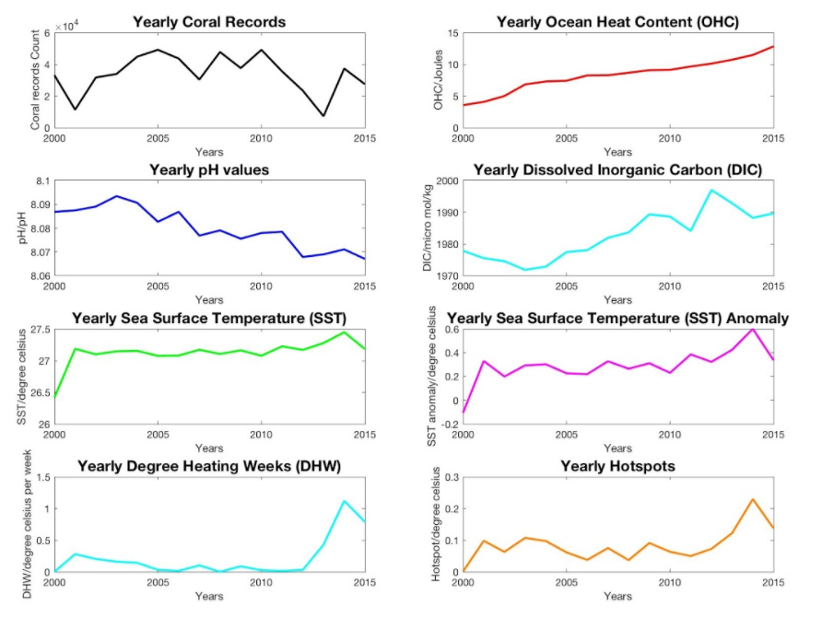**6. Discussion**

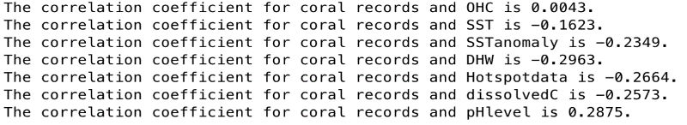

Figure 5: A plot of the different climate parameters and population of coral against time and statements indicating the correlation coefficient of each parameter to coral population.

Climate change parameters

Based on figure 5, we observed worsening climate conditions throughout the years (increasing temperature and decreasing pH). We also observed a negative correlation between all the climate indicators to coral population across time except pH (which had a positive correlation). OHC displayed a positive correlation despite being equivalent to SST and SSTa, rendering it an outlier. Therefore, our group chose to ignore it.

According to our research, worsening climate conditions extend El Nino years, thus shortening the gap periods of recovery between each El Nino event (NOAA, 2016). A shorter recovery time indicates a higher possibility of coral bleaching, resulting in death. Hence, we can conclude that climate change affects El Nino and is most probably associated with reducing coral numbers.

Analysis of Coral Species

Coral species were analysed only when data collected was continuous throughout 2000 to 2015. The species identified are Black Coral, Demosponge, Glass Sponge, Gorgonian Coral, Sea Pen, Soft Coral and Sponge. Based on figure 5, our group decided to study their change in population during the 2 most recent years which showed significant reduction in coral species (2010 and 2014). Upon further research, these 2 years were also recorded as global mass bleaching events.

After examining the changes (table 3), we classified them based on their change in population to the bleaching events. The first type (Soft corals and Demosponge) of corals show a decrease in numbers during both bleaching events. Hence, it is the least resilient since it unable to adapt to changing climate. The second type (Black coral and Sponge) shows an increase in the first event but a decrease in the second one, signifying a breached threshold due to worsening climatic conditions, resulting in death of that species. Hence, this group also has limited resilience. The third type (Glass sponge, Gorgonian Sponge) shows a decrease in the first event but an increase in the second one, signifying growing resilience to climatic factors as these corals can adapt to worsening conditions. Finally, the fourth type (sea pen) shows an increase in both events, indicating it is the most resilient species since it can adapt to both instances of changing climate.

Their increased resilience could be attributed to high gene flow within or between species that accelerates their recovery rate from recurrent bleaching (Hughes, 2013). However, more in-depth research will have to be conducted for individual species to account for such results.

**7. Limitations**

Firstly, our group understands that correlation between the parameters studied (climate change and coral population) may not necessarily mean causation. Next, climate change is a complex integration of different parameters. Hence, it is difficult to account for all the different factors and its combined impact on coral reefs. Also, the time frame chosen was constrained by the data available, preventing us from studying the impacts of the 2014 Mass bleaching event, which continued till 2017. Finally, there was limited data available as some coral sets had incomplete data.

**8. Conclusion**

In conclusion, climate change is associated with a reduction in coral population. Hence, we can observe a general decrease in resilience of corals towards climate change due to reduced recovery time. However, different species have varying levels of resilience to climate change. Corals that are more resilient include sea pen while the least resilient species include soft coral and demosponge. More research can be done to research on factors that make these corals resilient and potentially apply these findings to protect these reefs.

**References**

1. FOMA, A., Do, W., Are, W., Us, C., ATOLL, L., Wisdom, t., Shearwaters, P., Frigatebirds, B., Noddies, T., Landbirds, W., Birds, M., Birds, E., Life, M., Turtles, G., Seals, H., Dolphins, S., Invertebrates, F., Plants, N., Plants, N., Gazettes, G., Midway, V., INVOLVED, G., Debris, M., More, L., Give, J. and Cart, Y. (2017). *Pacific Ocean MPAs*. [online] Friends of Midway Atoll. Available at: https://www.friendsofmidway.org/pacific-ocean-mpas/ [Accessed 10 Nov. 2017]. Hoegh-Guldberg, O., Mumby, P., Hooten, A., Steneck, R., Greenfield, P., Gomez, E., Harvell, C., Sale, P., Edwards, A., Caldeira, K., Knowlton, N., Eakin, C., Iglesias-Prieto, R., Muthiga, N., Bradbury, R., Dubi, A. and Hatziolos, M. (2017). *Coral Reefs Under Rapid Climate Change and Ocean Acidification*.
2. Hughes, T. (2003). Climate Change, Human Impacts, and the Resilience of Coral Reefs. *Science*, 301(5635), pp.929-933.
3. IPCC, 2007: Climate Change 2007: Impacts, Adaptation and Vulnerability. Contribution of Working Group II to the Fourth Assessment Report of the Intergovernmental Panel on Climate Change, M.L. Parry, O.F. Canziani, J.P. Palutikof, P.J. van der Linden and C.E. Hanson, Eds., Cambridge University Press, Cambridge, UK, 976pp.
4. IPCC, 2014: Climate Change 2014: Synthesis Report. Contribution of Working Groups I, II and III to the Fifth Assessment Report of the Intergovernmental Panel on Climate Change [Core Writing Team, R.K. Pachauri and L.A. Meyer (eds.)]. IPCC, Geneva, Switzerland, 151 pp.
5. Oceanservice.noaa.gov. (2017). *What ocean basin has the most corals?*. [online] Available at: https://oceanservice.noaa.gov/facts/most_coral.html
6. Oceanservice.noaa.gov. (2017). *NOAA National Ocean Service Education: Corals*. [online] Available at: https://oceanservice.noaa.gov/education/kits/corals/coral07_importance.html [Accessed 10 Nov. 2017].
7. Noaa.gov. (2017). *El Niño prolongs longest global coral bleaching event | National Oceanic and Atmospheric Administration*. [online] Available at: http://www.noaa.gov/media-release/el-ni-o-prolongs-longest-global-coral-bleaching-event

**Appendix**

Figures used in the report are listed below

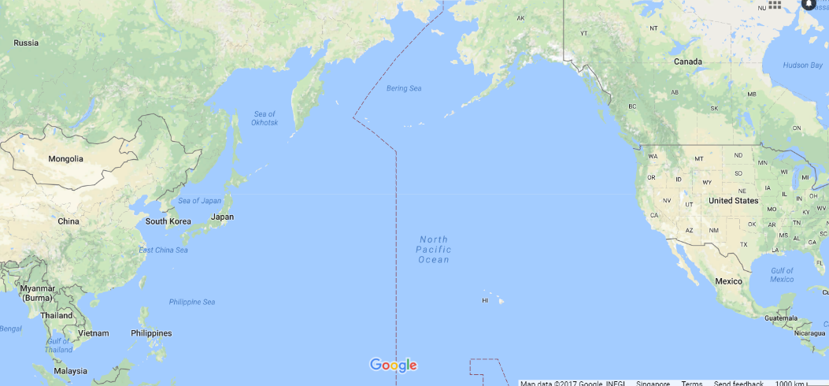

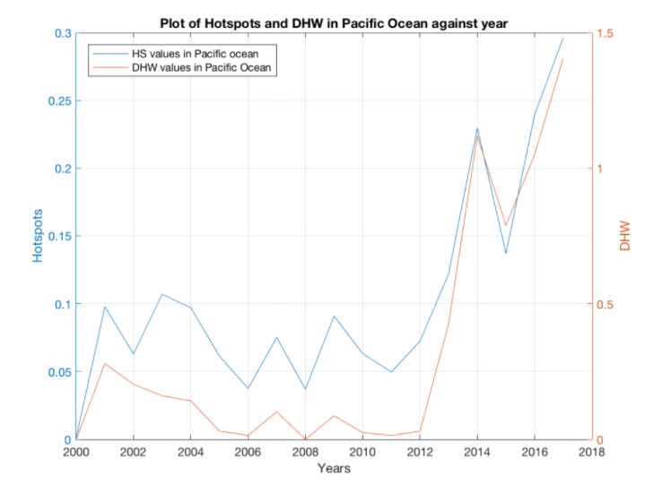Figure 1: Location of North Pacific Ocean

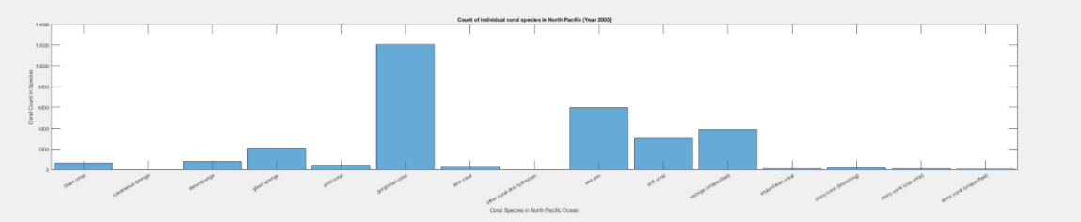Figure 2: A graph of the annual mean DHW and Hotspot data in North Pacific Ocean against time.

Figure 3: An example of the histogram plotted to show the number of each species of coral in North Pacific Ocean in 2003. Histograms were plotted from year 2000 to 2015.

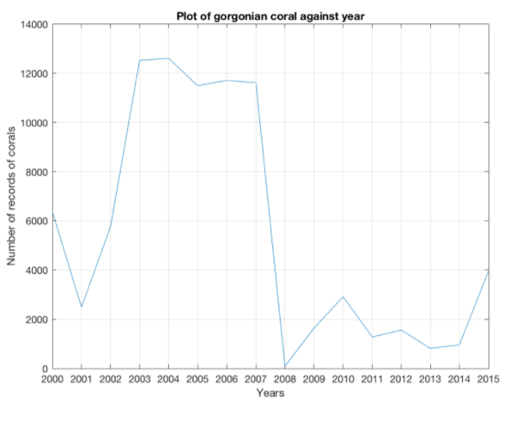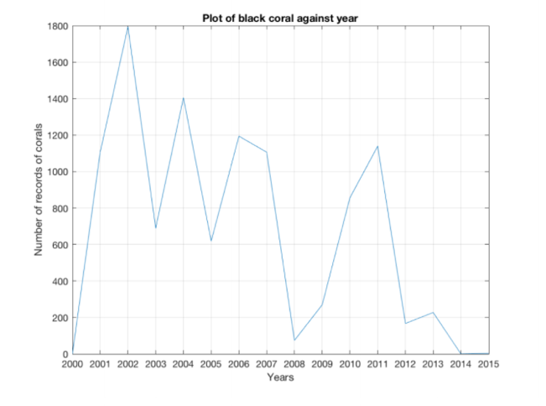

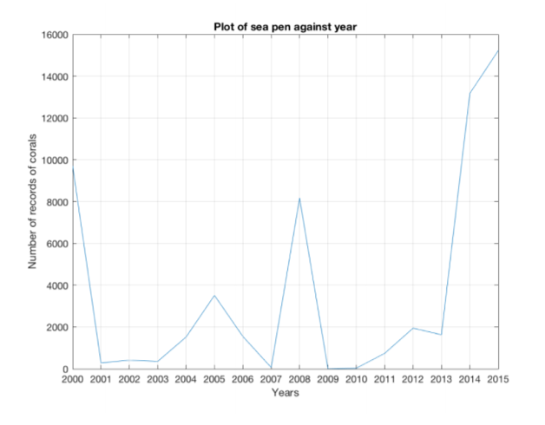

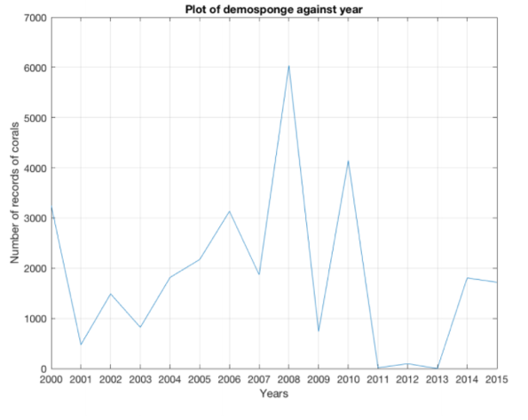

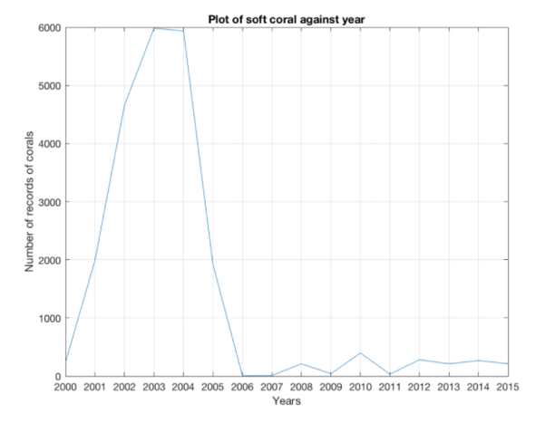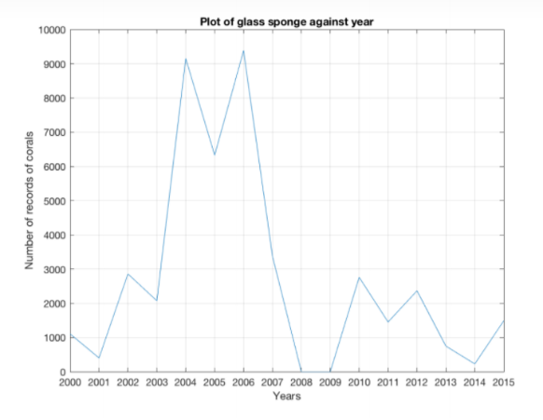

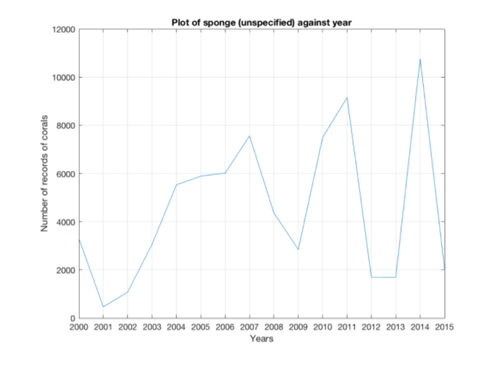

Figure 4: Graphs that show the quantity of each species from the year 2000 to 2015.

|  |  |  |  |
| --- | --- | --- | --- |
| **Individual Coral Species** | **Year 2010 - 2011** | **Year 2014 - 2015** | **Overall resilience** |
| Soft Coral | ↓ | ↓ | Least resilient |
| Black Coral | ↑ | ↓ | Threshold reached (Not adapted)  Limited resilience |
| Glass Sponge | ↓ | ↑ | Resilient  (Adapted) |
| Sea Pen | ↑ | ↑ | Most resilient |
| Gorgonian coral | ↓ | ↑ | Resilient  (Adapted) |
| Demosponge | ↓ | ↓ | Least resilient |
| Sponge | ↑ | ↓ | Threshold reached (Not adapted)  Limited resilience |

Table 3: A table that summarises the change in species population after the global mass bleaching event

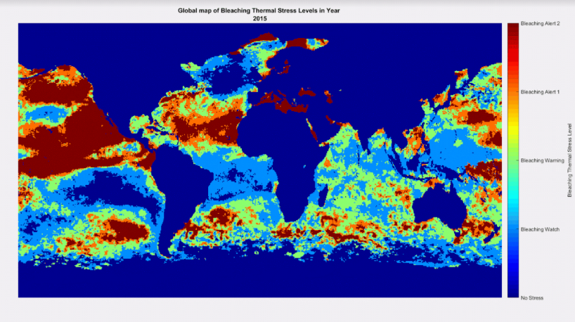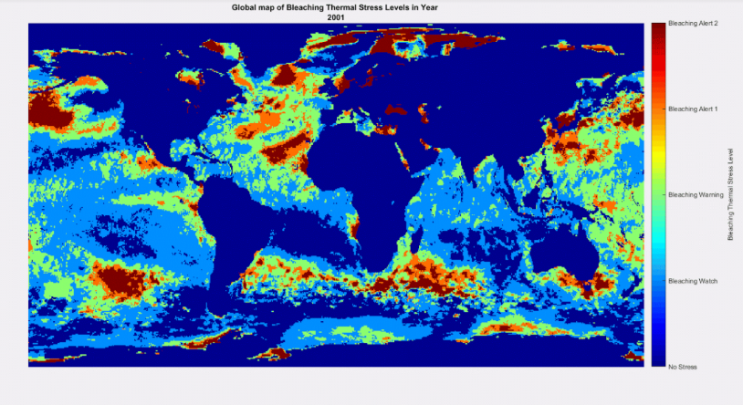

Figure 6: 2 plots on the world map showing the bleaching thermal stress experienced by corals. We can observe that bleaching stress has become more severe throughout the years.

**Distribution of work in Matlab Project:**

All group members were involved in sourcing for the datasets they will be working with and coding for. While there was an overlap of work contribution due to assistance provided to each other, the main work allocation was as below:

Nicholas and Kai Ting worked together to plot, correlate and analyse the climate change indicators with coral population used for Preliminary Analysis.

Reynold was responsible for plotting, animating and analysing the various bleaching datasets for Secondary Analysis.

Skye and Zeming worked together to plot, calculate and analyse the individual coral species count, distribution and resilience in face of worsening climate change for Final Analysis.

|  |  |
| --- | --- |
| Nicholas | 1. Sourcing data for ocean heat content 2. Obtaining yearly coral population data 3. Find the years where there is decrease in coral records 4. Calculating yearly sea surface temperature, sea surface temperature anomaly, dissolved inorganic carbon and pH levels 5. Plotting the above datasets,along with DHW and hotspot data into figures and analyzing them 6. Creating functions to read the coral and bleaching dataset (with help from Reynold and Ze Ming) 7. Final analysis of project |
| Skye | 1. Sourcing & downloading North Pacific deep-sea coral distribution data 2. Calculating and plotting individual coral species records across time 3. Plotting yearly coral distribution by color 4. Plotting histograms of coral species by year 5. Animated the figures in 3 & 4 6. Created a function and creating ***for*** loops to make ‘Climate change indicator script’ more efficient 7. Plotting linear best-fit line for OHC 8. Assisted in organising data to plot SST, SST anomaly, DHW Hotspot data in North Pacific Region on a map. 9. Final analysis of project |
| Kai Ting | 1. Obtaining yearly coral population data 2. Calculating the correlation between coral records and yearly sea surface temperature (SST), SST anomaly, dissolved inorganic carbon (nDIC), pH levels 3. Plotting the above datasets into figures and analyzing them 4. Final analysis |
| Ze Ming | 1. Sourcing for DHW, SST, SST anomaly, Hotspot data in North Pacific region 2. Source for CO2 and pH data in North Pacific Region 3. Calculating and plotting individual coral species records across time 4. Data conversion and extraction for coral species distribution 5. Calculating yearly DHW and hotspot data 6. Plotting histogram to show annual coral distribution among different species 7. Final analysis |
| Reynold | 1. Analysing degree of bleaching in North Pacific by plotting stations with recorded bleaching severity code on a map. 2. Analysing interpolated probability of bleaching occurrence between 1985 to 2010. 3. Helped Ze Ming plot SST, SST anomaly, DHW, Hotspot data on a map obtained from NOAA Coral Reef Watch Virtual Stations for each year. 4. Assisted in reading the dissolved inorganic carbon and pH levels data into MATLAB 5. Assisted in loading data of coral distribution into MATLAB. 6. Analyzing the final figures and drawing conclusions. 7. Assisted in creating animation for yearly coral distribution and histograms 8. Final analysis |

|  |  |  |  |
| --- | --- | --- | --- |
| **Individual Coral Species** | **Year 2010 - 2011** | **Year 2014 - 2015** | **Overall resilience** |
| Soft Coral | ↓ | ↓ | Least resilient |
| Black Coral | ↑ | ↓ | Threshold reached (Not adapted)  Limited resilience |
| Glass Sponge | ↓ | ↑ | Resilient  (Adapted) |
| Sea Pen | ↑ | ↑ | Most resilient |
| Gorgonian coral | ↓ | ↑ | Resilient  (Adapted) |
| Demosponge | ↓ | ↓ | Least resilient |
| Sponge | ↑ | ↓ | Threshold reached (Not adapted)  Limited resilience |

1. Cyclic El Nino patterns since 2000 generally occur once every 2 years for a period of 1 year.
2. Coral recovery time is defined as the period between 2 El Nino years. A coral that is bleached may be able to recover if given enough time before the next El Nino event. However, if the recovery time is too short, the bleached coral may die.